Greg Stone, CEO of Peach Tree Health, is committed to providing personalized, affordable, high-value health services to the medically underserved populations of California’s capital region. He’s focused on transforming the healthcare delivery model to stay ahead of industry
reforms and changes to ensure Peach Tree patients have access to the high quality care all patients deserve.

“By remaining creative and highly responsive to changes in healthcare, Peach Tree builds new opportunities for growth through partnerships, consolidations and clinical service contracting,” said Stone. “Through this process, it’s important for us to ensure a level of standardization for our staff and a warm and inviting environment for our patients, regardless of which facility they visit.”
· Located in Northern California counties of Butte,
· Operate 10 community health center sites and two
Sacramento, Sutter and Yuba
· Serve 33,000 patients through more than 100,000
mobile dental clinics
· Provide comprehensive medical, dental, vision and
visits each year
behavioral health services

FOCUSING ON THE QUALITY OF CARE
As a result of continued growth of Peach Tree Health, one of the biggest challenges for Stone and his staff has been ensuring consistent patient experience and care standards across the entire network.

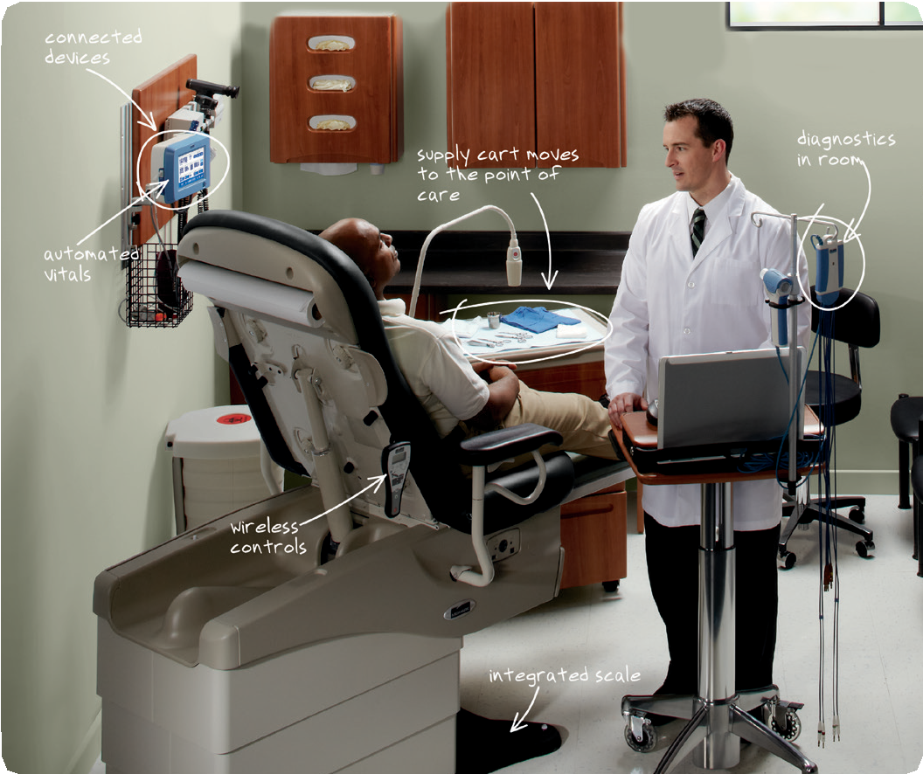
Stone enlisted the team at Midmark and their understanding of the point of care to help him realize
his goal of raising patient and staff expectations on what it means to visit and work in a community health center. Working together, the team created a template for exam room configuration and equipment that could be used to provide uniformity and consistency throughout the Peach Tree network of facilities.

Building a temporary exam room setting inside a conference room, Stone and the team brought in equipment and considered the experiences of patients and staff. How would someone with a walker or wheelchair navigate the space?
Did it make sense for certain equipment to be stored in a middle drawer, or higher in a hanging cabinet? Taking into consideration the ergonomic requirements of providers and patients, Stone and the team developed a workflow that met the diverse needs of a community health center.

Since then, Peach Tree has used the equipment and exam room configuration template in a variety of projects.

In one instance, Peach Tree built a new facility to replace an older, smaller location. Another project involved remodeling and modernizing an older health center,
while a third consolidated three facilities into one location. During all projects, Midmark worked closely with Stone and his staff to outfit the spaces with the right equipment and workflows to meet Peach Tree’s high standards of comfort, service and quality care.

“Structure and standardization are very important for our exam rooms and network of facilities,” said Stone. “By having a consistent exam room design with the same equipment and cabinetry configuration, our physicians and caregivers can easily move from room to room, facility to facility, and be familiar with the equipment and where things are stored. If you have to deal with different configurations and equipment
or struggle to find something because you don’t know where it is, you are wasting valuable time. That’s time that could be better spent with our patients.”

For Stone, the extra minutes saved through standardiza- tion don’t necessarily translate into his clinics seeing more patients in a day.

“At Peach Tree, we are not solely driven by the need
to squeeze more patient visits in a day. While we remain productive, we place an increasing emphasis on
quality visits and spending more time with our patients. It’s important that our patients feel truly cared for and that we spend the time necessary to provide quality care. Everyone at Peach Tree has a great respect for the provider-patient interaction.”

A VALUABLE PARTNER
While Stone is impressed with the quality, function and durability of the Midmark equipment Peach Tree uses throughout its facilities, he also sees the value Midmark brings to a project as providing expert counsel that results in better outcomes. For instance, Midmark was instrumental in Peach Tree’s efforts to move away from a centralized hallway vitals center.

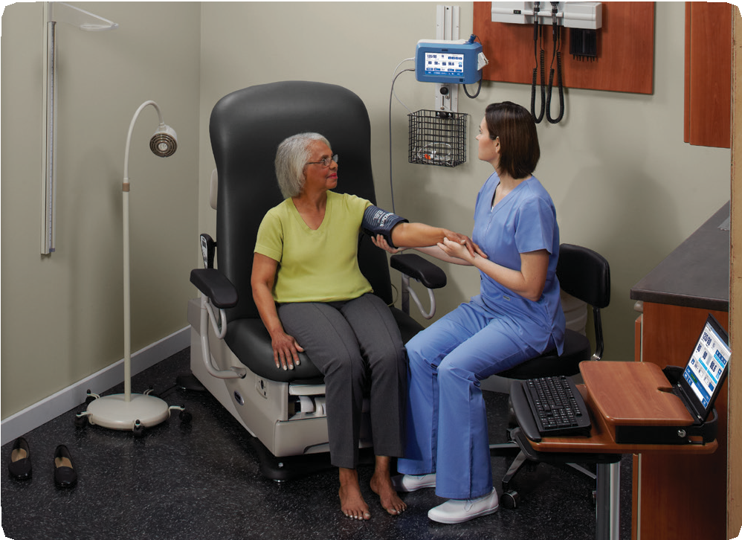

“Our patients really disliked our vitals process, especially being weighed in the public area.We worked with Midmark to consolidate the vitals gathering process
in the exam room. A key part of this is the Midmark 625 Barrier-Free® examination table with integrated IQscale®. It’s a great table. We integrated it with our electronic medical records (EMR) without having to spend a lot
of time and money on an interface. Now patients come in, get on the table, and we can take all their vitals from there. We can even take their weight with the table
and automatically transfer into our EMR – eliminating transcription errors and ensuring patient privacy.”

ONE LESS THING TO WORRY ABOUT

For Stone, partnering with Midmark means he has one less thing to worry about during projects.

“I’ve worked with other vendors who have not been nearly as involved in the exam room design phase as Midmark,” said Stone. “The Midmark team knows our clinics and what we are trying to accomplish. They understand how we use the equipment and are able to tell us what will and won’t work based on our needs, facility and the type of equipment and casework we want.

“I spend very little time worrying about how the project is progressing – I meet them at the site, we walk it, measure it and it’s done. They are super easy to work with and invest time and effort to really understand our needs and help us make the right decisions.
“When our patients walk into one of our fully refinished clinics, they are pleasantly overwhelmed with the environment and are eager to come back. Our
clinics and the equipment we have show them that they deserve the same level of care and Interaction as someone who goes to a private practice.

“When our patients are comfortable, they feel they are being listened to and cared for. We consistently receive high patient satisfaction scores and positive
feedback. They are more open to being compliant with recommendations to improve their health. They keep their appointments and encourage others to do so.
For us, this is one of the most important benefits of working with Midmark.”
· Midmark 625 Barrier-Free® examination tables
· Wall mounted IQvitals® monitors
· Care Exchange® workstation
· Synthesis® casework
· IQecg®
· IQspiro®
· Ritter 253 LED exam lights
· Ritter 272 air lift stools
· Midmark 640 pediatric exam tables
· Ritter M11 UltraClave® automatic sterilizer

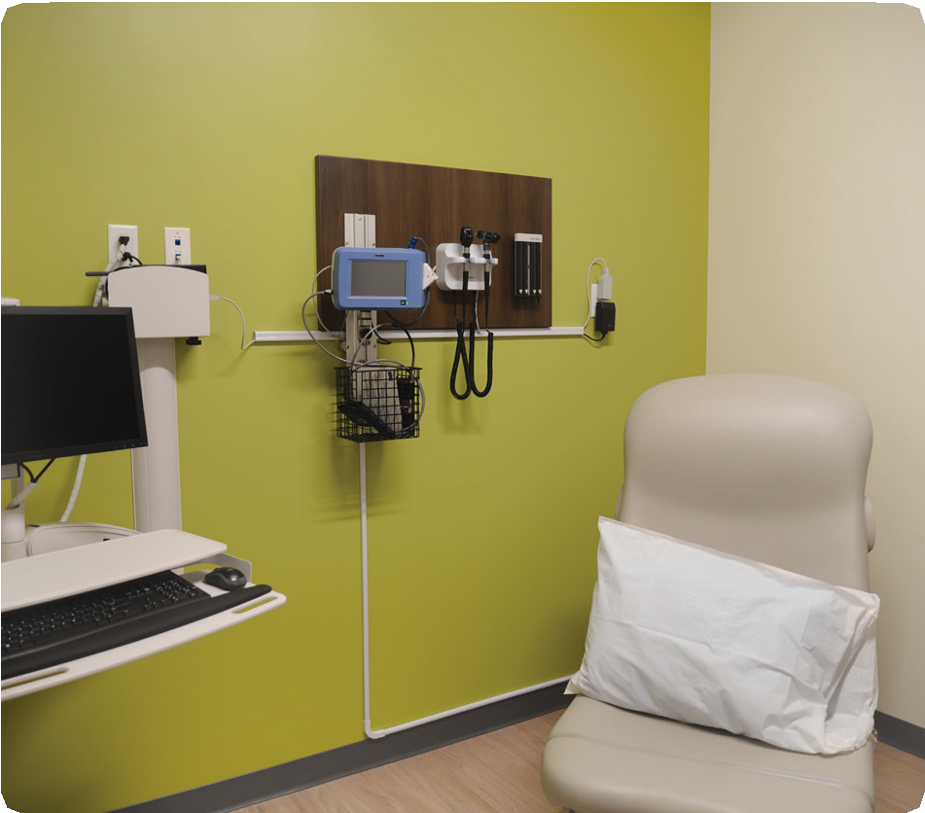

MKT-00104 Rev A1 (7/17)
Midmark Corporation, Dayton, OH.

